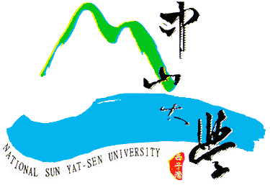
National Sun Yat-sen University Donation Form - Domestic

Date of submission: _____/____/____(yyyy/mm/dd)
Personal Details | Name
 | Phone number |  | Phone #: Mobile:
 | Mailing Address |  | □□□-□□
 | Email Address
 | Identity |  | □ NSYSU Faculty and Staff □ Business Organization □ General Public  □ NSYSU Alumni, Class year , graduation from the  Department/Institute/Class of __________________________
 | Company/  Institution |  |  |  |  |  | Title
Donation Details | Donation Amount |  | □ One-time donation: Amount:_________________________  □ Periodic donation: □monthly □yearly Amount:______________________
 | Designated Use |  | □ Donation designated to the Department/Institute/College  of_________________________________  □ Other designated use: _______________________________________  □ No designated use
Receipt | □ Receipt not required  □ Please send me the receipt for this donation  □ Please collect all receipts and send them to me at the end of the year
 | Name of Recipient:  □ Same as Donor(s)  □ Designated recipient: _______________________ |  |  |  | Address:  □ Same as mailing address  □ Other:______________________________
Ways to Give | □ Cash | Please complete this Form and submit to NSYSU Alumni Service Center to make donations.
 | □ Check | Please make checks payable to "National Sun Yat-sen University" and complete this Form. Send both check and Form by registered mail to NSYSU Alumni Service Center
 | □ Wire Transfer | BANK NAME：BANK OF TAIWAN KAOHSIUNG BRANCH  BANK ADDRESS：NO. 264 CHUNG CHENG 4TH ROAD,KAOHSIUNG CITY, TAIWAN, ROC  BENEFICIARY'S NAME：National Sun Yat-sen University Endowment Fund 401  ACCOUNT NO.：011-036032059  ※Please complete this Form and submit to NSYSU Alumni Service Center
 | □ Credit Card | Name of Cardholder |  |  |  | Card Type |  |  | □ VISA □ MasterCard  □ JCB
 |  | Card Number
 |  | Issuing Bank |  |  |  | Name of Cardholder  (Must be identical with credit card signature)
 |  | Expiration Date |  | / (mm/yy)
 |  | Security Code
Do you consent to allow your name, donated amount and designated use to be published on the NSYSU website or campus publications under the principle of public disclosure? □ Agree □Do not agree

Alumni Service Center, National Sun Yat-sen University
Address: 70 Lienhai Rd., Gushan Dist., Kaohsiung City 80424, Taiwan, R.O.C.
Phone: +886 7 525 5012 Fax: +886 7 525 6689 Email: ufrcaa@mail.nsysu.edu.tw

